24.4.20 OLI: to name key parts of a plant.

Write the names of the plant parts on the lines.

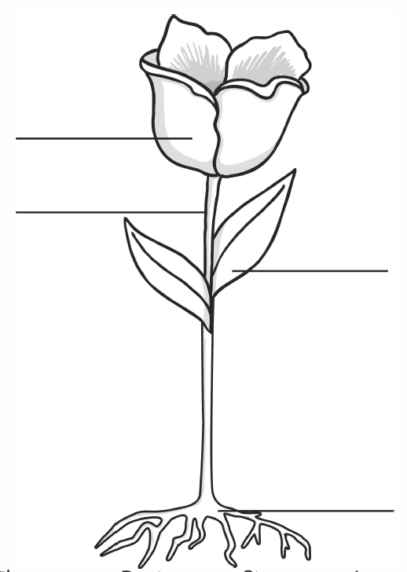

What flower do you think this might be?

_____________________________________________________

Useful words:

stem petal roots leaf

