14.5.20 Star Challenge
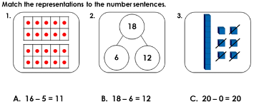

Now represent (show) each one in a different way.

