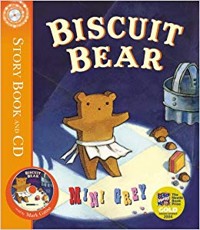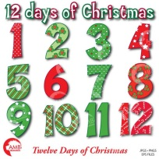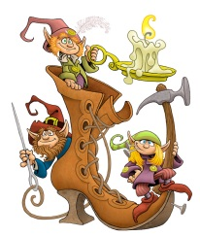0 Autumn Term

**Physical Development**

* I will be thinking about safety and taking risks
* I will be developing my physical skills - pushing, patting, throwing, catching and kicking (sports equipment)
* I will be developing my pencil control – anti-clockwise movement and retracing vertical lines
* I will be developing my fine motor skills including cutting and manipulating other tools

**Maths**

* I will be ordering numbers and use language ‘more’ or ‘fewer’ to compare sets of objects
* I can say the number that is one more than a given number
* I will be finding one more and one less from a group of object
* I will begin to use vocabulary involved in adding and subtraction
* I will be naming 2D (flat) shapes and using mathematical language to describe them
* I will be creating patterns
* I will be using everyday language related to money

**Expressive Arts and Design**

* I will be designing my own gingerbread man
* I will be creating a clay bear, using different tools to help me
* I will be experimenting with a range of materials and creating with a purpose
* I will role-play traditional stories with my friends
* I will be singing and performing as a group to an audience

**Personal, Social and Emotional Development**

* I will be choosing activities independently during the day which will empower me to be an active learner
* I will practise playing with other children, understanding that we play in different ways, respecting each other and our equipment
* I will be learning that actions have consequences
* Our Milford Value is RESPECT

**Understanding the World**

* I will be learning about Bonfire Night, Winter and Christmas
* I will be finding out about different materials and their properties
* I will be using computers to paint and move objects on a screen
* RE – What makes a place Special? Why do we have celebrations?

**Literacy**

* I will be listening to and reading traditional tales
* I will be learning to use story language and re-tell stories that I am familiar with
* I will be learning my phonics and keywords to help me read
* I will be reading and writing key words
* I will be practising correct letter formation

**How you could help at home….**

* *Talk about actions having consequences. What will happen if….*
* *Look for numerals in the environment – share the importance of numbers in our lives*
* *Describe everyday objects as 3D shapes e.g. a can of baked beans as a cylinder (cube, cuboid, sphere)*
* *Practise reading and writing keywords*
* *Visit parks, museums and libraries*

**Communication and Language**

* I will be learning how to follow instructions
* I will be explaining and understanding prepositions e.g. behind, under, on
* I will be learning new words and using them in conversation with my friends
* I will talk with my Learning Partner at carpet time, listen to their ideas and share them with the class

**Year R – Once Upon a Time Autumn Term (2)**