1. Kay has these coins. How much money does she have in total?
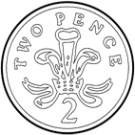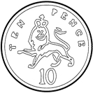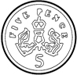

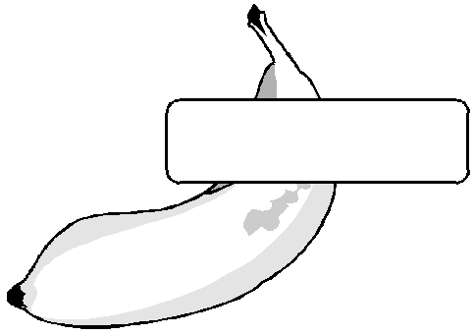
2. Amy wants to buy a banana using 2p coins. How many coins does she need?
banana 18p

How did you work it out?

3. Hannah buys a packet of crisps for 15p and an apple for 5p. How much money does she spend?

4. I buy a ball for 15p and pay with a 20p coin. How much money do I have left?

5. Draw coins to make 12p in two different ways.

Star Challenge

I have 5 round silver coins in my purse. How much money could I have?
How many different answers can you find?

