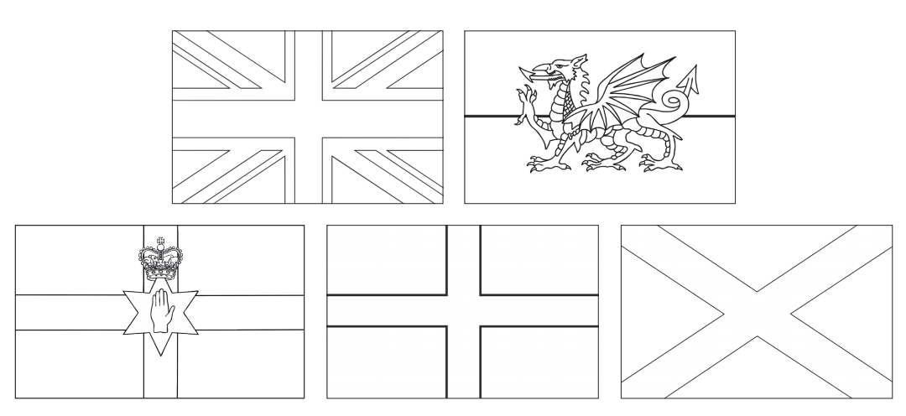
OLI: To name the four countries of the United Kingdom

In school we learned the names of all the countries of the United Kingdom; England, Scotland, Wales and Northern Ireland. You might remember that we made a puzzle out of them and talked about the capital cities. The Union Flag is the flag for the whole of the United Kingdom but each country has its own flag as well. Can you cut them out (or copy the pictures), colour them in and stick in your home learning book? Label each flag with its country name.
Can you research the answers at home yourself? If you don’t have what you need, there is some information on the next page.
Star Challenge
Can you write the capital city of each country under the flag?

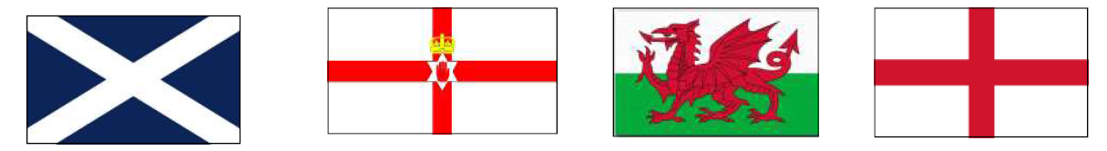
Scotland Northern Ireland Wales England

