MILFORD SCHOOL
Termly Expectations
EYFS – Year 2
Grow, Learn, Believe, Achieve

November 2016

Milford School Termly Expectations – Early Years
 | Reading | Writing | Numbers
Autumn | Hears and says all sounds in cvc words  Secure with key words up to  set 5  Continues a rhyming string  Name half the letters of the alphabet  Secure at Phase 2 letters and sounds | Can write name  Writes initial sounds of words  Ascribe meaning to marks  Holds pencil static tripod (3rd stage) | Count objects and actions to at least 10  Count back from 10 to 0  Recognise numerals 0 – 10  Uses language more and fewer to compare  One more and one less with numbers 1- 9  Can find the total of two groups by counting all of them  Record using marks  Solve problems by sharing
Spring | Can blend sounds in cvc words  Secure with key words to set 12  Can name all letters of the alphabet  Know that information can be retrieved from books | Link sounds to letters as they write simple cvc words  Write independently during play  Write labels and captions | In practical activities use language involved in adding and subtracting  Write the numbers 0 – 10  Count back from 20 – 0  Solve problems by doubling
Summer | Secure with Phase 3  Can decode regular words using their phonic knowledge  Read and understand simple sentences  Secure with key words to set 17  Know that capital letters and full stops demarcate a sentence  Secure reading red band books | Use phonic knowledge to write words in ways that match their spoken sound  Write simple sentences which can be read by themselves and others  Write some irregular common words | Count reliably to 20  Order numbers from 0 – 20  Recognise which number is one more and one less  Add and subtract two single digit numbers and count on and back to find the answer  Solve problems by doubling, halving and sharing
Early Learning Goal | Children read and understand simple sentences. They use phonic knowledge to decode regular words and read them aloud accurately. They also read some common irregular words. They demonstrate understanding when talking with others about what they have read. | Children use their phonic knowledge to write words in ways which match their spoken sounds. They also write some irregular common words. They write simple sentences which can be read by themselves and others. Some words are spelt correctly and others are phonetically plausible. | Children count reliably with numbers from one to 20, place them in order and say which number is one more or one less than a given number. Using quantities and objects, they add and subtract two single-digit numbers and count on or back to find the answer. They solve problems, including doubling, halving and sharing.

End of Autumn term expectations for English – Year 1

Writing  By the end of Year 1 we aim for your child to be a creative writer who can write a series of sentences independently. | Reading  By the end of Year 1 we aim for your child to enjoy reading, read simple texts independently and be able to discuss what they have read.
Vocabulary, Grammar and punctuation. (Organisation and purpose)  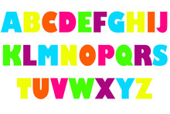  - Leave spaces between words.  - Recognise full stops and capital letters.  - Use full stops and capital letters in writing.  - Use topic related words.  Composition  - Compose sentences orally before writing them.  - Use a sentence structure by chaining clauses together.  - Use adjectives to make work more interesting (Blue sky, sparkly diamond).  - Produce ideas related to a range of high quality texts.  Transcription (Spelling and Handwriting)  - Begin to correctly spell high frequency words.  - Segment and spell words containing adjacent consonants. (e.g boost, burnt).  - Write letters using the correct sequence of movements.  - Most letters are clearly shaped.  - Most letters are correctly orientated. | Word reading  - Recall phoneme/grapheme correspondences. (Sound /letter).  - Read common words by sight e.g. their, called, asked, could etc.  - Recognise common graphemes and common alternative pronunciations.  - Read phonically decodable two and three syllable words  - Begin to read with phrasing and fluency to support meaning.  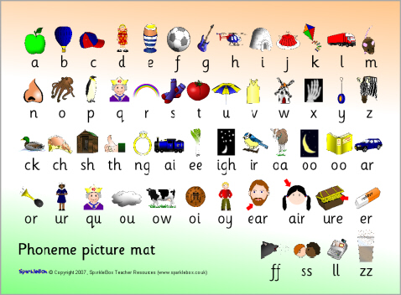  Comprehension  - Understand and use the correct terms when sharing a text; book, cover, beginning, end, page, word, letter, line.  - Recall the main points in a shared text.  - Use story structure when retelling a story.  - Listen to familiar texts and identify likes and dislikes.  - Read non-fiction texts and identify the differences between fiction and non-fiction.

End of Spring term expectations for English – Year 1

Writing  By the end of Year 1 your child is expected to be a creative writer who can write a series of sentences independently. | Reading  By the end of Year 1 it is expected that your child will enjoy reading, read simple texts independently and be able to discuss what they have read.
Vocabulary, Grammar and punctuation. (Organisation and purpose)  - Use adjectives to make work more interesting (Blue sky, sparkly diamond).  - Introduce prepositions (inside, outside, towards, across, under).  - Use question marks.  - Use ‘and’ to link ideas.  - Choose appropriate vocabulary linked to subject matter.  - Use capital letters for common nouns.  Composition  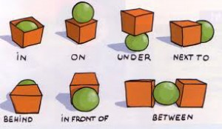  - Write meaningful words and phrases expressing ideas.  - Start to use story openers (Once upon a time, one sunny day).  - Have some indication of purpose e.g. message, story, label.  - Story writing follows a simple structure. (3 part beginning, middle and end).  Transcription (Spelling and Handwriting)  - Write the correct grapheme for a given sound.  - Use diagraphs, trigraphs and split diagraphs when spelling new words. (ai, igh, a-e)  - Spell the days of the week.  - Begin to add –ed,-ing,-er, - est independently.  - Use the prefix ‘un’ ( unhappy, unpack) | Word reading  - Read words with contractions e.g. I’m or we’ll  - Read words with simple suffixes such as ‘s’, ‘es’ and ‘ing’ e.g. fish, fishes and fishing  - Recognise punctuation when reading. (Capital letters, full stops, question marks, exclamation marks).  - Self-correct inaccurate reading.  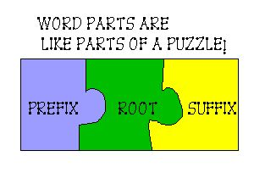  Comprehension  - Select a book for personal reading and explain choice.  - Recall information from the text and highlight parts that are of interest.  - Compare stories and make predictions (e.g. What usually happens to the bad characters?).  - Answer basic questions about a text (Who? What? Where? How?).  - Recognise how the text is organised. (Front cover, contents page).

End of Summer term expectations for English – Year 1

Writing  By the end of Year 1 your child is expected to be a creative writer who can write a series of sentences independently. | Reading  By the end of Year 1 it is expected that your child will enjoy reading, read simple texts independently and be able to discuss what they have read.
Vocabulary, Grammar and punctuation. (Organisation and purpose)  - Write sentences with clear spaces between words.  - Join ideas together using words such as and, but, with, so etc.  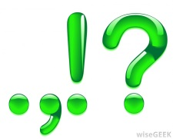  - Begin to punctuate sentences using:  - Capital letters  - Full stops  - Questions marks  - Exclamation marks  - Use capital letters for names and I.  - Read what they have written and check that it makes sense.  Composition  - Write a sequence of sentences to form a short story.  - Write a sequence of informative sentences to present facts.  Transcription (Spelling and Handwriting)  - Name all letters of the alphabet.  - Use knowledge of sound letter links to write words.  - Spell all days of the week.  - Spell key words such as was, you, are etc.  - Use simple suffixes including ‘ing’, ‘ed’ and ‘er’  e.g. playing, played and player .  - Use regular plural such as ‘s’ and ‘es.’  e.g. dog, dogs or wish, wishes.  - Use the prefix ‘un’  - e.g. unkind, untie etc.  - Correctly form all lower case letters using cursive script (starting and finishing in the right place).  - Correctly form all capital letters. | Word reading  - Quickly recall phoneme grapheme correspondences (sound letter links).  - Use knowledge of phonics (sound letter links) to read unknown words.  - Read common words by sight e.g. their, called, asked, could etc.  - Read words with contractions e.g. I’m or we’ll.  - Read words with simple suffixes such as ‘s’, ‘es’ and ‘ing’ e.g. fish, fishes and fishing.  - Read simple texts with confidence and fluency.  - Recognise capital letters, full stops, question marks, exclamation marks and ellipsis (….).  - Begin to use punctuation cues to aid pace and intonation e.g. pauses at full stops, use voices for speaking characters.  - Re-read if reading does not make sense and self-correct.  Comprehension  - Enjoy reading.  - Know the difference between fiction and non-fiction text.  - Discuss poems, stories and non-fiction texts and explain their understanding of them.  - Relate reading to their own experiences.  - Retell familiar stories e.g. fairy tales or a series of events.  - Identify and join in with predictable or repetitive phrases.  - Talk about simple word meanings.  - Make simple inferences on the basis of what has been said or done.  e.g. ‘What does this tell us about the character?”.  - Predict what might happen on the basis on what has been read.  e.g. “What might the story be about and what makes you think that?”.

End of Autumn term expectations for Maths – Year 1

Number | Measurement
Number and place value  - Say numbers up to 20, both forwards and backwards from any given number  - Say a number 1 more or less for numbers up to at least 20  - Represent numbers up to at least 20 using objects and pictorial aids such as a number line  - Count, read and write numbers up to 20  - Read and write numbers in words from 0 to 5  - Count in multiples of 2s up to 20  - Understand the language of equal to, more than, less than, fewer, most and least  Addition and subtraction  - Read number sentences that use +, - and =  - Be able to derive bonds and subtraction facts to at least 10  - Add and subtract single digit numbers  - Solve simple addition and subtraction using objects or pictorial aids  Multiplication and division  Fractions  - Identify, name and find a half of an object or shape | - Directly compare length, height and use language such as long, longer, longest etc.  - Measure and begin to record lengths and heights using non-standard units  - Sequence events in chronological order using appropriate language (e.g. morning, afternoon, evening)  - Recognise and use language relating to days of the week and years  - Tell o’clock time  - Know the values of coins less up to at least 10 pence
 | Geometry
Properties of Shape
- Recognise and name common 2d and 3d shapes

Position and Direction
- Follow and give instructions involving position, direction and movement
- Distinguish between left and right

End of Spring term expectations for Maths – Year 1

Number | Measurement
Number and place value  - Say numbers up to 50, both forwards and backwards from any given number  - Say a number 1 more or less for numbers up to at least 50  - Represent numbers up to at least 50 using objects and pictorial aids such as a number line  - Count, read and write numbers up to 50  - Read and write numbers in words from 0 to 12  - Count in multiples of 2s and 10s  - Begin to use the language of equal to, more than, less than, fewer, most and least  Addition and subtraction  - Read and begin to write number sentences that use +, - and =  - Begin to use bonds and subtraction facts up to at least 10 and derive bonds and subtraction facts to 20  - Add and subtract numbers up to 20 e.g.  a single digit from a 2 digit less than 20  - Solve simple addition, subtraction and missing number problems (e.g. 11 = - 9) using objects or pictorial aids  Multiplication and division  - Represent multiplication and division using objects, pictorial aids and arrays  5 + 5 + 5 = 15  3 x 5 = 15  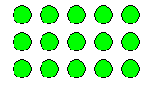  Fractions  - Identify, name and find a half of an object shape or quantity  - Identify, name and find a quarter of an object or shape | - Compare mass/weight and capacity using language such as heavy, light, full, empty etc.  - Measure and begin to record mass/weight, capacity and volume  - Sequence events in chronological order using appropriate language (e.g. first, next, then)  - Recognise and use language relating to months  - Tell o’clock and half past times  - Know the value of coins up to at least £2.00
 | Geometry
Properties of Shape
- Recognise and name common 2d and 3d shapes

Position and Direction
- Describe position, direction and movement
e.g. left, right, forwards, backwards

End of term expectations for Maths – Year 1 Summer Term

Number | Measurement
Number and place value  - Say numbers up to 100, both forwards and backwards from any given number  - Say a number 1 more or less and 10 more or less  - Represent numbers using objects and pictorial aids such as a number line  - Count, read and write numbers to 100  - Read and write numbers in words from 0 to 20  - Count in multiples of 2s, 5s and 10s  e.g. 2, 4, 6, 8 and so on  - Understand and use the language of equal to, more than, less than, fewer, most and least  Addition and subtraction  - Read and write number sentences that use +, - and =  - Use bonds and subtraction facts to 20  e.g. 20 + 0 = 20, 19 + 1 = 20, 18 + 2 = 20 or 20 – 7 = 13, 20 – 6 = 14  - Add and subtract numbers up to 20  - Solve simple addition, subtraction and missing number problems (e.g. 11 = - 9) using objects or pictorial aids  Multiplication and division  - Solve simple multiplication and division problems using objects, pictorial aids and arrays e.g. There were 2 elephants, they both ate 6 bananas. How many bananas were eaten altogether?  Fractions  - Identify, name and find a half or quarter of an object, shape or quantity | - Compare length, height, mass/weight and capacity using language such as long, longer, longest, heavy, light, full, empty etc.  - Measure and begin to record lengths, heights, mass/weight, time, capacity and volume  - Sequence events in chronological order using appropriate language (e.g. first, next, then or morning, afternoon, evening or yesterday, tomorrow)  - Recognise and use language relating to days of the week, months and years  - Tell o’clock and half past times  - Know the value of coins and notes
 | Geometry
Properties of Shape
- Recognise and name common 2d and 3d shapes
2d shapes such as rectangles and circles
3d shapes such as cuboids, pyramids and spheres

Position and Direction
- Describe position, direction and movement
e.g. whole, half and quarter turns

End of Autumn term expectations for English – Year 2

Writing  By the end of Year 2 your child is expected to be a confident independent writer, who is able to write at length for a range of purposes. | Reading  By the end of Year 2 it is expected that your child will read fluently and independently.  They will be able to answer key questions about what they have read.
Vocabulary, Grammar and punctuation. (Organisation and purpose)  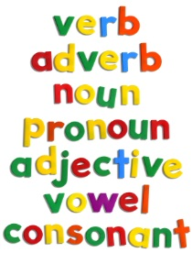  - Various types of sentence can be written e.g. statement, question and command.  - Writing will use expanded noun phrases to add description (e.g. the dark spooky woods)  - A wider range of punctuation will be used correctly. (Full stops, capital letters, question marks, exclamation marks).  Composition  - A narrative with some detail of character, setting and plot can be created.  - Simple additions and corrections are able to be made to a narrative to make it even better.  Transcription (Spelling and Handwriting)  - Common phonically decodable two and three syllable words are able to be spelt correctly.  - Handwriting shows that upper and lower case letters not mixed within words.  - Use simple suffixes including ‘ing’, ‘ed’ and ‘er’ e.g. playing, played and player .  - Use regular plural such as ‘s’ and ‘es.’ e.g. dog, dogs or wish, wishes.  - Correctly form all lower case letters using cursive script. | Word reading  - Use phonemes to help read unfamiliar texts (digraphs, trigraphs and split diagraphs).  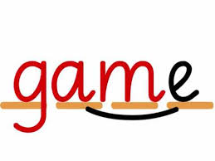  - Reading is accurate by blending the sounds in words that contain the common graphemes and alternative sounds for graphemes.  - Expression is used when reading.  - A wider range of tricky words can be read.  Comprehension  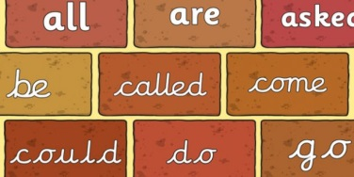  - Comments on plot, setting and characters in familiar and unfamiliar stories are able to be made.  - Events within a book can be understood and sequenced.  - Greater independence is shown when predicting what may happen next within a story.  - Relate content to own experience and knowledge.  - Identify and discuss how texts are organised.  - Begin to identify a range of punctuation.

End of Spring term expectations for English – Year 2

Writing  By the end of Year 2 your child is expected to be a confident independent writer, who is able to write at length for a range of purposes. | Reading  By the end of Year 2 it is expected that your child will read fluently and independently.  They will be able to answer key questions about what they have read.
Vocabulary, Grammar and punctuation. (Organisation and purpose)  - Use a wide range of sentence openings.  - Understand adverbs and using them in various forms of writing.  - Write using subordination (when, if, that, because) to join sentences together.  - Use past and present tense.  - Use varied and interesting vocabulary. (adjectives, alliteration, similes)  - Use story language. (e.g. suddenly)  Composition  - Recognise character features and describe a character with simple detail.  - Show clear links in writing between events and ideas.  - Show personal viewpoint by comments or questions about events.  Transcription (Spelling and Handwriting)  - Common exception (“tricky”) words spelt accurately  - Add suffixes to nouns (e.g. add –er, -est; plurals – es, - changing y to ies)  - Spell the days of the week and months of the year are accurately (including use of capital letters) | Word reading  - Read a wider range of high frequency words.  - Read with phrasing and fluency, taking note of punctuation to keep track of longer sentences.  - Apply knowledge of graphemes with alternative pronunciations when reading texts.  - Self-correct when reading does not make sense.  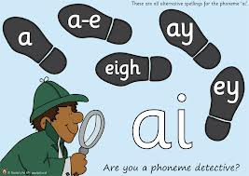  Comprehension  - Show an understanding of text by commenting on main events and characters.  - Locate key vocabulary and specific information in the text to answer questions.  - Use contents and index to help retrieve information.  - Make predictions by using experience of reading a range of texts.  - Use a range of clues from the text to express simple opinions.
End of Summer term expectations for English – Year 2

Writing  By the end of Year 2 your child is expected to be a confident independent writer, who is able to write at length for a range of purposes. | Reading  By the end of Year 2 it is expected that your child will read fluently and independently.  They will be able to answer key questions about what they have read.
Vocabulary, Grammar and punctuation. (Organisation and purpose)  - Write different kinds of sentence: statement, question, exclamation, command.  - Use expanded noun phrases to add description and specification. (e.g. the dark spooky woods)  - Use a wider range of sentence openings (e.g. adverbs)  - Write using subordination (when, if, that, because).  - Use and understand present tense and past tense.  - Consistent use of a wider range of punctuation: capital letters, full stops, questions marks, exclamation marks and commas in a list.  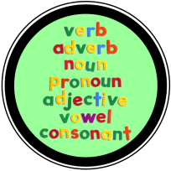  Composition  - Create a narrative with some detail of character, setting and plot.  - Use organisational features of non-fiction text (titles, sub headings, illustrations and captions)  - Express their own viewpoint by simple comments or actions.  - Make simple additions and corrections to their writing.  Transcription (Spelling and Handwriting)  - Accurately spell common phonically decodable two and three syllable words  - Add suffixes to nouns (e.g. add –er, -est; plurals – es, - changing y to ies)  - Common exception (“tricky”) words spelt accurately  - Correctly use an apostrophe for omission of letters (wasn’t didn’t it’s).  - Spell the days of the week and months of the year are accurately (including use of capital letters)  - Clear letter formation, with ascenders and descenders distinguished,.  - Upper and lower case letters not mixed within words | Word reading  - Read at a fluent pace, taking note of punctuation.  - Read accurately by blending the sounds in words that contain the common graphemes and alternative sounds for graphemes  - Use expression when reading.  - Read accurately more complex words of two or more syllables (e.g. downstream, hideaway, comfortable)  - Read a wider range of exception (tricky) words.  - Read words containing common suffixes.  - Check the text makes sense and self-correct inaccurate reading.  Comprehension  - Comment on plot, setting and characters in familiar and unfamiliar stories.  - Discuss the meanings of words, linking new meanings to known vocabulary.  - Demonstrate understanding by sequencing events in books  - Look through a variety of books with growing independence to predict story development  - Make inferences on the basis of what is being said and done  - Identify words and phrases chosen for effect on the reader  - Discuss their favourite words and phrases  - Recognise simple recurring literary language in stories and poetry  - Locate key vocabulary and information in fiction texts to find answers to simple questions  - Find information in non-fiction, making full use of non-fiction layout

End of Autumn term expectations for Maths – Year 2

Number | Measurement
Number and place value  - Begin to understand the place value of each digit, use this to order numbers to at least 100  - Recognise sequences of number including odd and even numbers and continue a number sequence that increases or decreases in regular steps  - Count sets of objects reliably including grouping objects in 10s, 2s and 5s  Addition and subtraction  - Recognise subtraction is the inverse of addition  - Begin to understand subtraction as ‘difference’ and use a number line to record  - Know by heart all addition and subtraction facts for each number to 10  - Use mental calculation strategies to solve simple problems using addition and subtraction involving money and measures  - Identify doubles and halves of numbers up to 20  - Recognise coins to 50p and choose coins to make amounts up to 50p  - Use the symbols + - and = to record number sentences  Multiplication and division  - Begin to understand the operation of multiplication as repeated addition  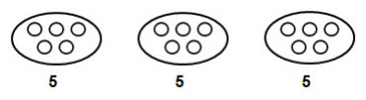  - Begin to understand division as repeated subtraction or sharing  Fractions  - Begin to use halves and quarters in practical situations e.g. sharing sweets between four and getting a quarter each  - Relate the concept of half of a small quantity to the concept of half of a shape e.g. shade one half or one quarter of a given shape | - Begin to use standard units to measure and compare quantities and objects  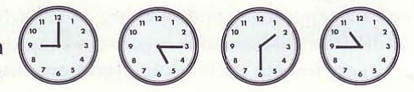  - Tell the time using hours, half-hour and quarter-hours
 | Geometry
Properties of Shape
- Identify 2D and 3D shapes from pictures
- Make and talk about shapes referring to features and properties, such as edges, faces etc.
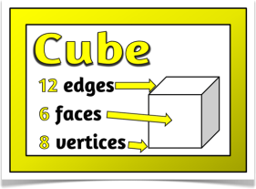

- Sort 2D and 3D shapes according to a single criterion

Position and Direction
- Follow and give instructions involving position, direction and movement
- Distinguish between left and right

 | Statistics
- Understand vocabulary relating to handling data, such as sort, group, set, list, table, most common, most popular
- Organise and classify data using simple lists and tables
- Enter data on to a simple computer database
- Communicate their findings, using simple lists, tables, pictograms and block graphs

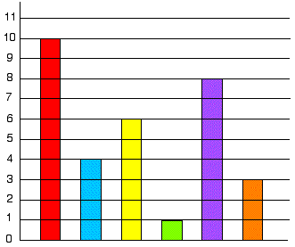
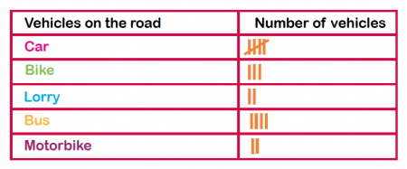
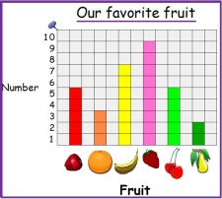
- Respond to questions about the data they have presented
End of Spring term expectations for Maths – Year 2

Number | Measurement
Number and place value  - Count, read, write and order accurately to at least 100  - Explain what each digit represents in any 2 digit number  - Describe and extend simple number sequences (including odd and even numbers)  Addition and subtraction  - Use place value to derive facts such as 30 + 70 = 100  - Know by heart facts for the 2x and 10x tables  - Use mental strategies to solve simple problems using +/-, doubling and halving, explaining methods and reasoning orally  - Add or subtract mentally a multiple of 10 to/from a 2 digit number  - Choose the appropriate operation when solving addition and subtraction problems  - Recognise all coins and choose coins to make amounts up to £1  - Recognise equivalent amounts of money  - Record mental calculations as number sentences using + - x ÷ and = symbols  Multiplication and division  - Understand the operation of multiplication as repeated addition  - Begin to see multiplication as an array and represent on a number line  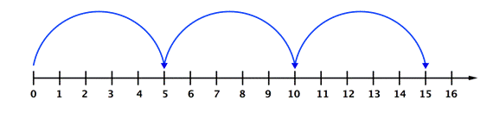  5 + 5 + 5 = 15  3 x 5 = 15  - Understand division as repeated subtraction or sharing  - Understand halving as a way of ‘undoing’ doubling  Fractions  - Begin to understand and use unit fractions such as ½ ¼ 1/3 of shapes | - Begin to make sensible estimates in relation to familiar units  - Read scales to the nearest labelled division  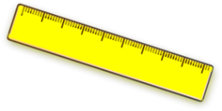  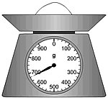  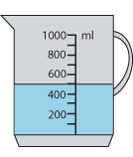  - Order events using a timeline
 | Geometry
Properties of Shape
- Recognise right angles in 2D shapes
- Understand that the properties of shapes remain the same regardless of size and orientation

Position and Direction
- Recognise and explain that a shape stays the same even when it is held up in different orientations
 | Statistics
- Collect and sort data to test a simple hypothesis
- Sort objects and classify them using more than one criterion

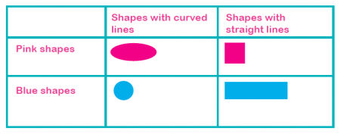
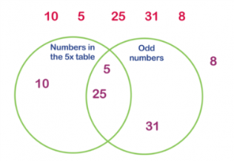
- Interpret data presented in simple lists, tables, pictograms or block graphs
- Pose questions for others about their data
End of term expectations for Maths – Year 2 Summer Term

Number | Measurement
Number and place value  - Count in steps of 2,3 and 5 from 0, and in tens from any number, forward and backward  - Recognise the place-value of each digit in a two-digit number (tens and ones)  - Compare and order numbers from 0 to 100; use <, > and = signs  - Read and write numbers to 100 in numerals and words  - Use place value and number facts to solve problems  Addition and subtraction  - Solve problems with addition and subtraction using concrete objects, pictures and mentally with up to two 2-digit numbers and 3 1-digit numbers  - Apply mental and written methods  - Recall addition and subtraction number facts to 20 and use related facts to 100  - Know that addition can be done in any order and that subtraction cannot  - Recognise the inverse of addition and subtraction problems and use to check calculations and solve missing number problems  e.g. 14-6=8 check using 8+6=14, 20- =5, check using 20-5=  Multiplication and division  - Recognise odd/even numbers  - Recall multiplication and division facts for the 2, 5 and 10 times tables  - Record using x, ÷ and = signs  - Know that multiplication can be done in any order but that division cannot  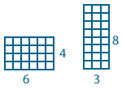  - Solve problems using materials, repeated addition,  arrays and mental methods, including in problems  in contexts  Fractions  - Recognise, find, name and write fractions ¼ , 2/4, ¾ and ⅓ of a length, shape or number  ¼ of 8 is 2  - Write simple fractions, e.g. ½ of 6 = 3 and to recognise equivalence of ½ and 2/4 | - Choose and use appropriate standard units; m/cm, kg/g, l/ml and °C  - Compare and order length, mass, volume/capacity and record results >, < and =  - Recognise and use symbols pounds (£) and pence (p) and combine amounts to make a particular value  - Find different combinations of coins to make the same amount  - Solve simple problems involving adding and subtracting money in a practical context, including giving change  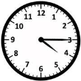  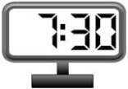  - Compare and sequence intervals of time  - Tell the time to five minutes, including quarter past/to  and draw hands on a clock to show these  - Know the number of minutes in an hour and hours in a day
 | Geometry
Properties of Shape
- Identify and describe the properties of 2-D and 3-D shapes, including number of sides, vertices (corners) and faces

- Find a line of symmetry on a 2-D shape

- Compare and sort 2-D and 3-D shapes and everyday objects

Position and Direction
- Order and arrange objects in patterns and sequences
- Use mathematical vocabulary to describe position, direction and movement, including in a straight line and rotation as turn in term of right angles for quarter, half and three-quarter turns (clockwise and anti-clockwise)

 | Statistics
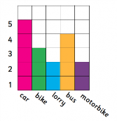
- Interpret and construct simple pictograms,
tally charts, block diagrams and simple tables

- Ask and answer questions by counting the number of objects in each category and sorting the categories by quantity
- Ask and answer questions about totalling and comparing data

