7.5.20 Star Challenge
We are learning that if we know that 1 and 9 make 10, we also know that 10 and 90 make 100.

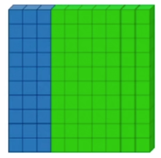

This is a picture of 10 dienes. This is a picture of 100 dienes.
There are 3 blue dienes and 7 green. Three groups of 10 are blue and 7 groups of 10 are green.
(So, 30 are blue and 70 are green.)
3 + 7 = 10 30 + 70 = 100

Fill in the missing numbers in these number sentences then try the puzzle over the page.

1 + 9 = 10 10 + 90 = 100
2 + 8 = 10 20 + 80 = 100
3 + 7 = 10 + 70 = 100
4 + 6 = 10 40 + = 100
5 + 5 = 10 50 + 50 =

Write a number sentence to match this picture.
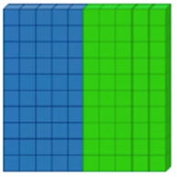

Cut out the triangles and then put the shape back together. The pairs of numbers are number bonds to 10 or number bonds to 100.
Good luck!
