Place Value
The value of a digit is changes depending on its place in a number.

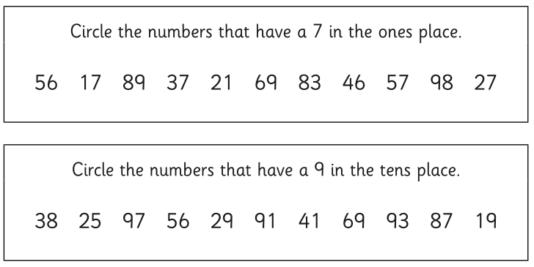
Mild challenge

Spicy challenge
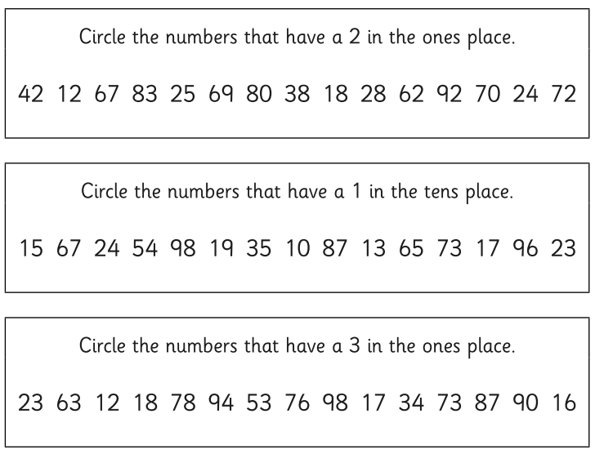
Hot challenge

Say the numbers out loud and talk about what you know about some of them.
Everyone can have a go at this challenge. The first one has been done for you.
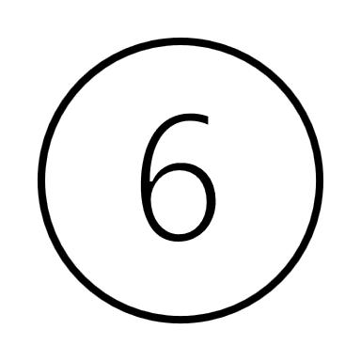
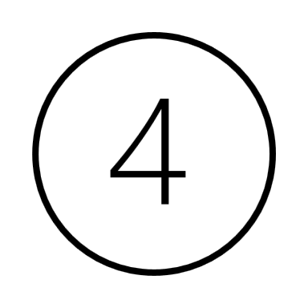

4
64
60

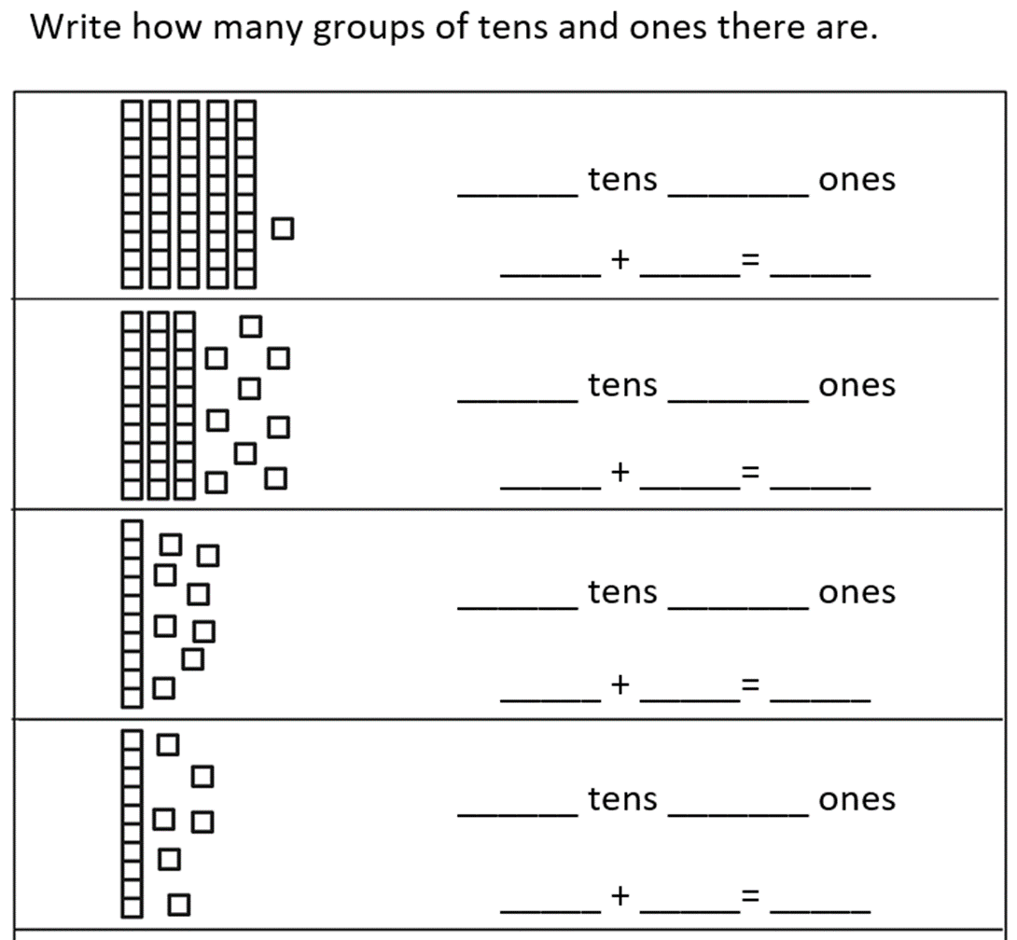
Your turn.

Now draw this number.
3 tens and 2 ones
30 + 2 = 32

Remember our problem solving steps to success.
- Read the question 3 times.
- Find the important information.
- Look at what you know.
- Look for what you need to find out.
- Draw a picture to help you.
- Double check.

Hint:
Draw Ava’s number first, then add to your drawing to make Max’s number.

