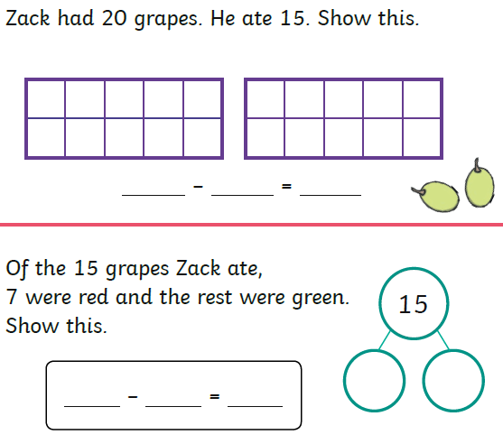

Find the answer to these calculations and then show me how you worked it out.

20 – 17 =

17 – 7 =

17 – 8 =

