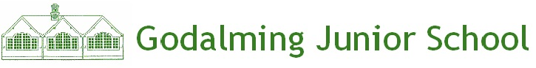
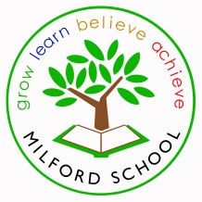
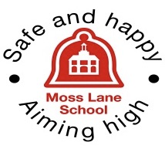

Busbridge

Infant School
Godalming Learning Partnership
(A mutual schools co-operative education trust)
Consultation
The Reason for the Consultation
The Governing Bodies of Busbridge Infant School, Godalming Junior School, Milford School and Moss Lane School are proposing to change their legal school category from community to foundation and, at the same time, acquire charitable status as a shared co-operative Trust; to be known as;
Godalming Learning Partnership.
This is a summary of the full Proposal, which provides further detail and is available at our school as well as electronically from our website.
What we would like you to do
We would like to know what you think of our proposals so we invite you to take part in our public consultation. You can do this by:
- Reading this information and asking for further information if you need any.
- Attending one of the consultation meetings - details are shown below.
You can respond to the consultation:
- By completing the Proposal Consultation response forms, which are available from the school
- By sending comments or requests for further information by email to the schools listed below:
- By sending comments or requests for further information in writing to:
Consultation c/o The Governing Body
Busbridge Infant School, Hambledon Rd, Godalming GU7 1PJ 01483 417898
Website: www.busbridge-infant.surrey.sch.uk Email: consultation@csnetwork.coop
Godalming Junior School, Hallam Rd, Surrey GU7 3HW 01483 421597
Website:www.godalming-junior.surrey.sch.uk Email:consultation@csnetwork.coop
Milford School, Church Rd, Godalming GU8 5JA 01483 422087
Website: www.milford.surrey.sch.uk Email:consultation@csnetwork.coop
Moss Lane School, Moss Lane, Godalming GU7 1EF 01483 417214
Website: www.moss-lane.surrey.sch.uk Email: consultation@csnetwork.coop

We want to consult widely about this Proposal to ensure all interested parties have their say.
If you know of any other stakeholders who should be contacted, please inform the school.
A number of consultation meetings where you can find out more have been arranged as follows:

Tuesday 2nd October 2018
9.15 a.m Parents and Public Busbridge Infant School
10.45 a.m Pupil Group Busbridge Infant School
12.00 noon Union Godalming Junior School
1.15 p.m Pupil Group Godalming Junior School
4.00 p.m Staff Godalming Junior School
6.00 p.m Parents and Public Godalming Junior School
7.00 p.m Open Meeting Godalming Junior School
Parents/Staff/Local Community from Godalming Confederation Schools

Wednesday 3rd October 2018
9.15 a.m. Parents and Public Moss Lane School
10.30 a.m. Pupil Group Moss Lane School
1.30 p.m. Pupil Group Milford School
4.30 p.m. Staff Milford School
6.00 p.m. Parents and Public Milford School

Parents and public meetings are open to all parents and public.
Staff meetings are open to all staff but heads may want to target a particular meeting for their whole staff group.

- The Governing Bodies and the leadership teams of Busbridge Infant School, Godalming Junior School, Milford School and Moss Lane School have been considering how best to plan for the long term future of the school, in the light of changes happening in the public education service.
- We want to ensure that we continue improving the service we offer to our children and young people and we want to become part of a regional and national network of schools and partners that can help us to deliver that ambition.
- To take this plan forward, we are proposing to change the school category from community to foundation and at the same time to acquire (establish) together a co-operative education trust, to be called The Godalming Learning Partnership
- The proposed date of implementation (i.e. the date on which any legal change of category would take place and the Trust would be created on) is 1st December 2018
- The process of change will not result in noticeable day to day differences for our school, but we believe that setting up this partnership will allow us to join a group of like-minded education providers and learn from the shared expertise and experience they offer.
- Further information is provided below – we would be pleased to hear what your thoughts are and invite you to become a member of the Trust so that you can contribute to its work if we do go ahead.
- You are invited to comment on these proposals at any time until the end of the consultation period, which runs from 21st September to 12th October 2018.

8. Our vision for this education Trust.

The Godalming Learning Partnership will work collectively to ensure that all children in our area receive the highest quality education, whilst valuing each school’s autonomy and uniqueness.

We will use the collective capacity of our schools to:
- maximise the progress and achievement of every young person in our community,
- improve transition for all our learners across each key stage,
- use collective resources to broaden and enrich the learning opportunities for our community,
- develop long-term sustainable partnerships between schools, other education providers and external partner organisations.

9. The values on which we base our education Trust.
As a co-operative education trust, we adopt and support the values and principles of the co-operative movement in our work:

- self-help
- self-responsibility
- democracy
- equality
- equity and solidarity

- honesty
- openness
- social responsibility and caring for others.

