21.4.20 OLI: to recognise different coins and their value.

Find as many different types of British coins as you can.
Ask a grown-up to help you wash them and then try these challenges.
- Arrange the coins in order, from the least to most valuable.

- Look closely at the coins? What is the same or different about them?

- Do the coins all look the same? Can you see the shield in this picture? Try to make your own. You could make rubbings of the coins and draw any missing bits.

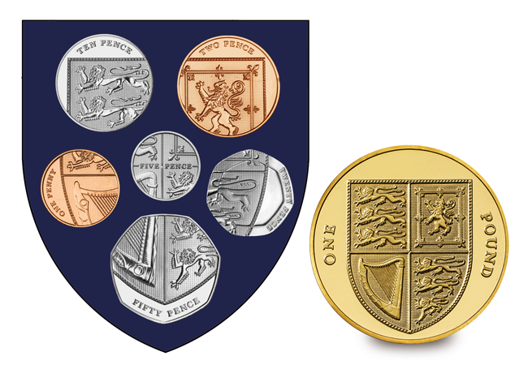

- How many different types of the same coin can you find? Do you have any coins with unusual pictures on?
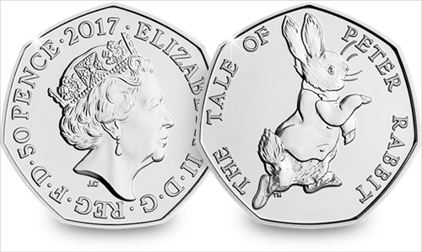
Mrs Hearsum has this one …

- Play the coin sorting and ordering games at https://www.topmarks.co.uk/money/coins-game

Star Challenge
Mrs Hearsum wants to buy 6 stickers that cost 10p each. Can she buy them with the Peter Rabbit coin? Why?

