Autumn Term

**Physical Development**

* I will be learning different ways of travelling and taking weight on different body parts
* I will be learning the importance of exercise, eating, sleeping and hygiene to keep me healthy
* I will be using a pencil effectively to form recognisable letters

**Personal, Social and Emotional Development**

* I will be learning how to show empathy towards others
* I will understand that I can make choices about how to behave and that choices have consequences
* I will be learning how to manage angry feelings
* I will be learning about people who care for me
* I will be learning that we can take medicines to make us feel better and know that some things are dangerous

**Year R – On the Move**

**Spring 2**

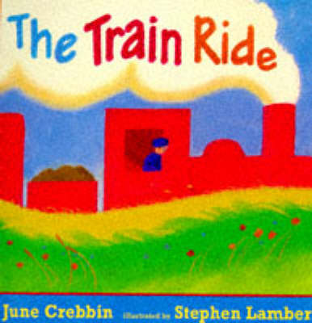

**Communication and Language**

* I will be learning to listen attentively

and respond to ideas

* I will be learning to follow a story

without pictures

* I will be learning to use talk to organise, sequence and clarify my thinking

**How you could help at home... **

* Encourage independence at home like getting their uniform ready the night before
* Talk about being considerate to others and showing self-control
* Encourage writing for a purpose like birthday cards, notes, party invitations
* Practise keywords and reading
* Visit the park and go for walks to look for seasonal changes and the arrival of Spring

**Literacy**

* I will be using my imagination to help me write my ideas
* I will be writing sentences that can be read by myself and others
* I will be sequencing stories
* I will be decoding words/using my keywords to read simple sentences
* I will be talking about what I have read and retelling a story

**Maths**

* I will be reading, writing and ordering numbers to 10 (and beyond)
* I will be saying one more and one less than a given number
* I will use the words of ‘more’ and ‘fewer’ to compare two sets of objects.
* I will find the total number of

objects by counting all of them

* I will use language to explain addition and subtraction
* I will talk about everyday objects and shapes (2D and 3D) and use mathematical language to describe them.
* I will recognise and create patterns
* I will talk about time and solve problems

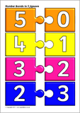

**Expressive Arts and Design**

* I will be using what I have learnt about media and materials in original ways
* I will role-play with my friends in our creative areas
* I will enjoy exploring the structure of sound in rhythm and rhymes through singing and action songs and playing musical instruments

**Understanding the World**

* I will be investigating different ways of travelling and programming Beebots to move.
* I will be learning about different celebrations for different people e.g. Easter,
* I will be talking about what we can learn from different stories (RE)

