21.4.20 OLI to name some common plants and flowers

Plants and Flowers Hunt
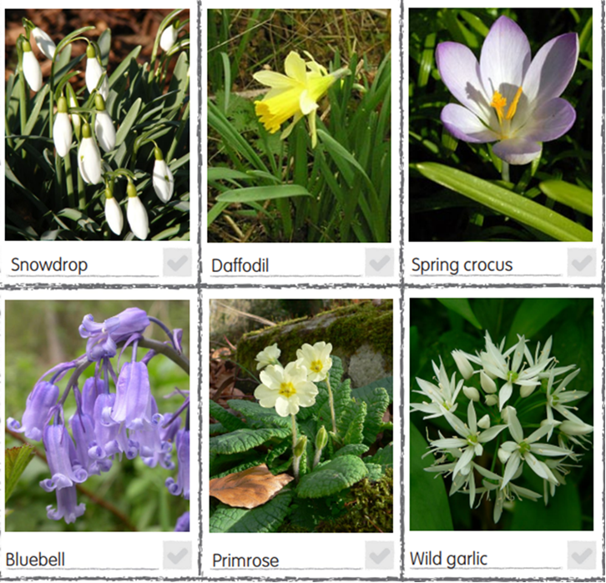
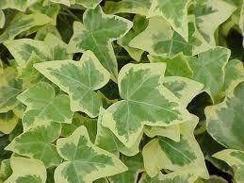
Tick the plants and flower you have found.
Ivy

Have you seen any other flowers that you can name?

Have you spotted any other plants or flowers that you know the names of?

