OLI: to compare different animals and explore adaptation
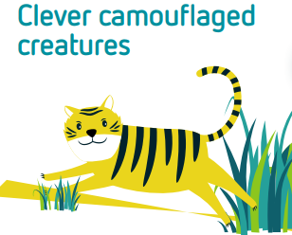

What you need:

- Butterfly shapes cut out of brown or grey paper (or any plain colour).
- Pencils/felt tips/paint/crayons/scissors.
- Objects to hide eg. Brightly coloured piece of wool/fabric, toy animals in their natural colours, square of white paper (6cm x 6cm approx.), other objects of your choice.

Instructions
- Use the cut-out paper butterflies to explore camouflage by finding ways to hide them around the room/garden. Talk about how camouflage works.

- How easy is it to hide creatures that are a plain colour? Some animals, such as snakes, use patterns to hide. Others, like stick insects, use their shape to try to stay hidden. There are other ways of camouflaging as well.

- Take it in turns to hide the other objects as quickly as you can. You are not allowed to cover them up.
Think about: Which object do you think will be easiest to hide? Why do you think this? Where will it be best to hide them? Will anyone be able to find them? What if you change the colour of things? What about their shape? Can you see a pattern that might help? Do you think some places are better for hiding the objects? Why do you think this is?

Try putting each of them in different places. Where are they difficult to see? Why do you think that is? Where can they be seen very easily? Why do you think that is? Can you do other things to help to camouflage them?

Next steps Challenge
You could make a collage of lots of different creatures that often use camouflage.
Do you or a friend have a pet? If yes, where would camouflage hide them?
Use the facts below to do some research of your own.
- Animals like big cats have spots or stripes to blend with their surroundings.
- Zebras’ stripes make it difficult for a predator to know where one animal ends and the other begins.
- Some animals have special skin that can change colour. Chameleons are the most famous of these.
- Female animals are sometimes better camouflaged than the males. This is so that they are not seen when sitting on the nest or looking after their babies.
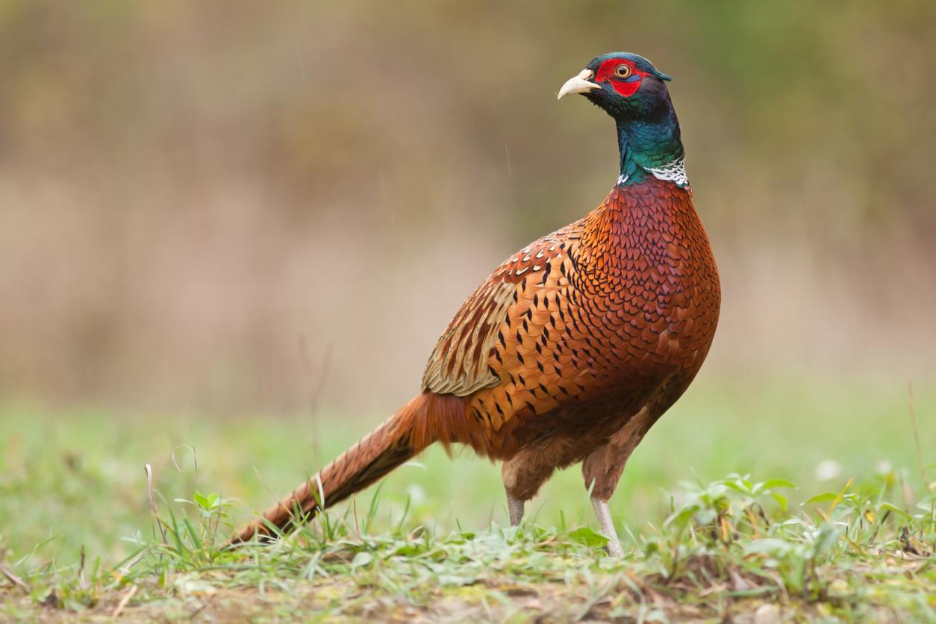
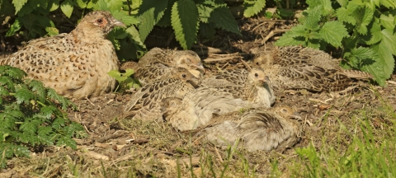 Pheasant

