OLI: to identify and name a variety of common deciduous and evergreen trees

Notes for parents:
Please discuss the OLI with your child. What do identify and variety mean?
Cut and stick the pictures (or draw your own if preferred) and label the different trees.
Can you see any of these trees from your house or spot any if you are on a daily walk?
If you have these or other trees around you then leaf rubbings or pressing leaves would be a great extension to the learning.
What other trees do you know?
We will focus on the difference between deciduous and evergreen in another session but if you can spot which trees have full leaves now and which are just emerging that would be great.

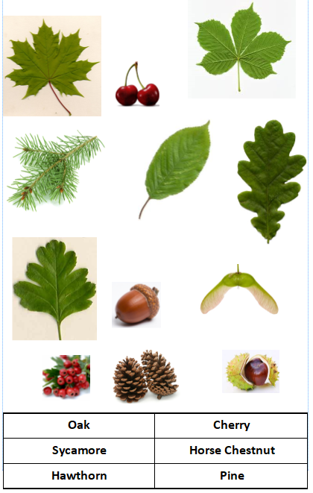
Match the labels to the tree.

