2.4.20 OLI: to solve simple mathematical problems by adding three numbers.

Notes for parents:
Some children will find this learning more tricky than others. It is fine to work practically without recording anything until your child is comfortable. The challenge questions are not for everyone - you should ensure your child is challenging themselves at an appropriate level.
Warm up
Practise counting to 20 in 2s and 60 in 5s.
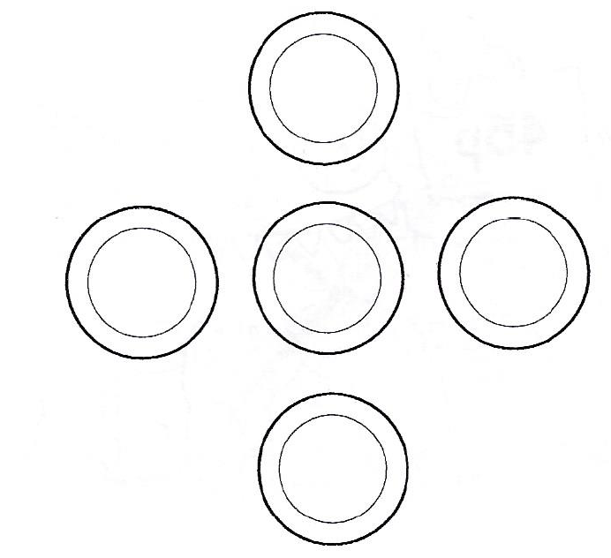
Part 1
Find 15 small objects - count and double check.
Put 5 plates or circles of paper in a cross shape (see picture).
Use all 15 objects.
Put a different number on each plate.
Make each line add up to 10.
Discuss.

Part 2
Do it again but this time make each line add up to 8.

Star Challenge
Write an addition number sentence to represent each line.

Need another challenge?
Is there a pattern?
Ask your child to try different combinations of plate and counter numbers. Can they reason about what is happening?
What if you had 10p coins? How many coins would you need to make each line add up to £1?

