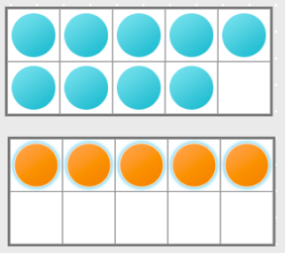

9 + 5 = 15

Jack uses a tens frame to find the total of 9 and 5.

Do you agree with him? __________

Explain why.
____________________________________________________________________________________________________________________________________________________________
Draw the correct tens frame.

