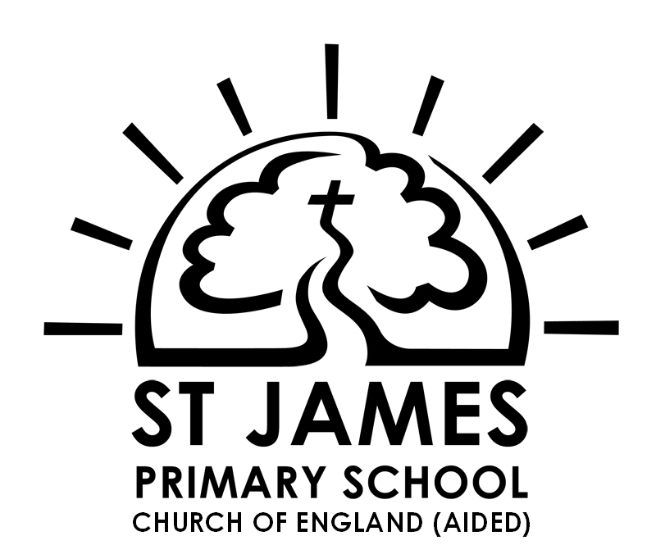

*Milford School*

*Church Road*

*Milford*

*Surrey*

*GU8 5JA*

**Godalming Confederation of Schools**

**www.godalmingconfederation.org.uk**

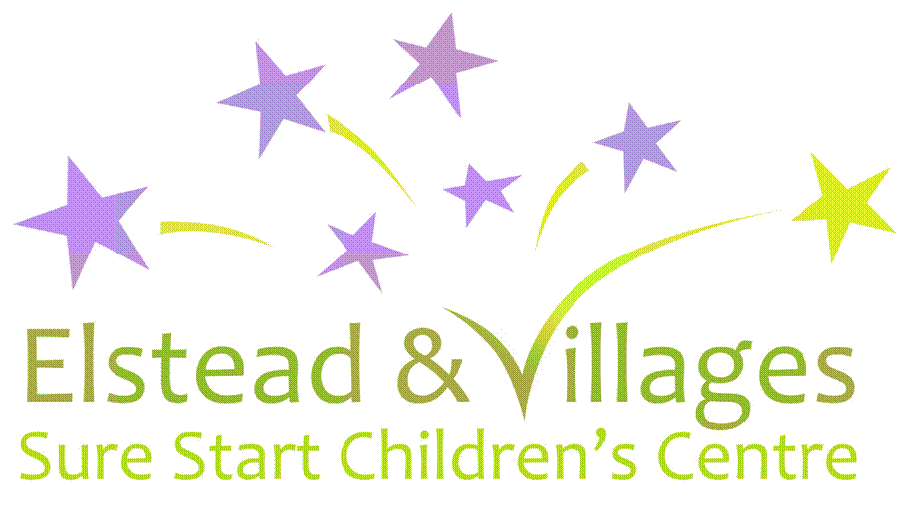

21st September 2018

The Godalming Confederation includes the children’s centres, nursery, infant, junior, primary and secondary schools in Godalming and surrounding area. Our eleven schools are working together to form a new co-operative education partnership.

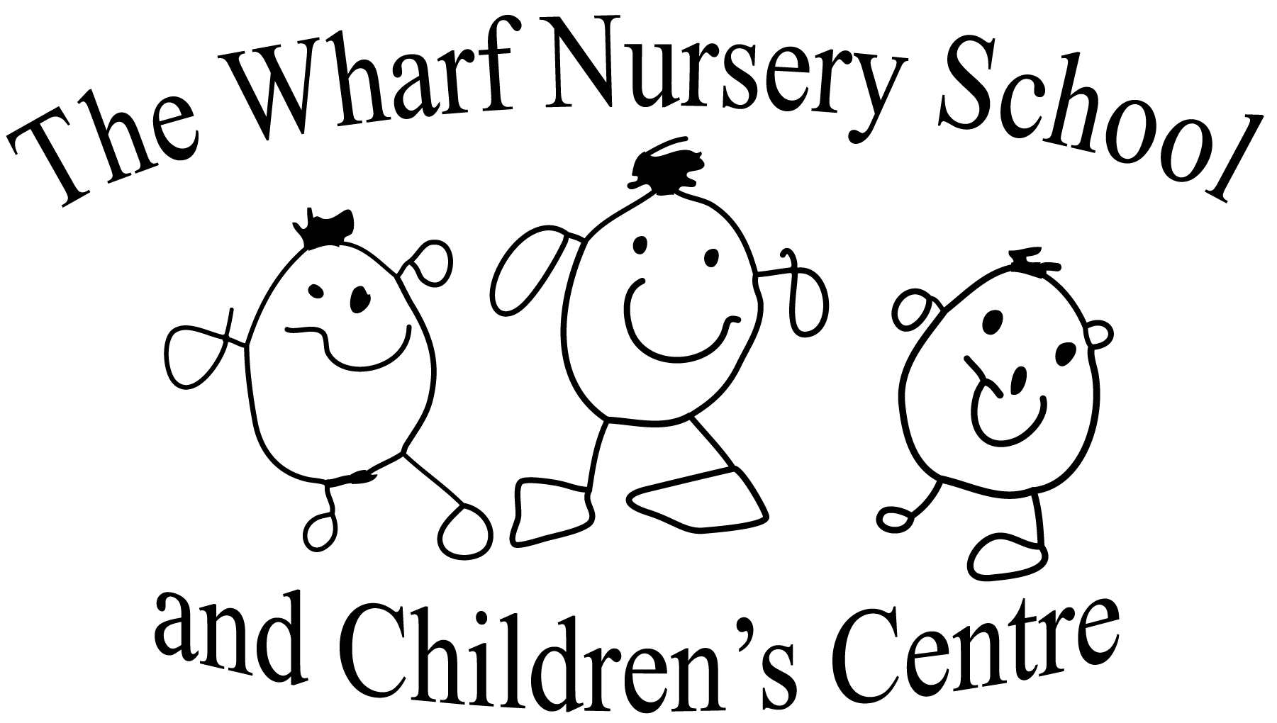

Our schools collaborate to provide training and development opportunities for staff; review each other’s performance; share good practice and develop common strategies and practices to further improve standards of learning and outcomes for all children in our area.

Broadwater School



Over the last two years, discussions between all of the schools have led to the conclusion that the partnership working is valuable and should be developed further through a legal structure which also protects each school’s autonomy.

The proposed model is a co-operative learning trust, which will offer benefits for all of the confederation schools including:

* Sustainability: a formal co-operative legal entity with powers to commission shared support, contracting and other work as agreed jointly



**Farncombe Infant and**

**Nursery School**

**Church of England (Controlled)**

* Opportunity: further expansion of shared training, professional development, staff retention and recruitment and curriculum enrichment for our learners.
* Flexibility: the choice of agenda and priorities, negotiated between the schools
* Autonomy with accountability: continuing independence for each school, with shared goals for school performance and school improvement

**A Legal Consultation**

In order to set up the co-operative partnership, four community schools: Busbridge Infant School, Godalming Junior School, Milford School and Moss Lane School are proposing to change their legal school category from ‘community’ to ‘foundation’.



**Godalming Junior School**

This then allows the legal entity of Godalming Learning Partnership to come into being.

The implications for the other schools in Godalming Confederation are straightforward, involving a flexible commitment to working on agreed projects of shared interest for the benefit of children and young people attending schools in the group.



There are no changes to individual school management, staffing, uniforms or day to day routines – the Trust will create new opportunities which can be used when appropriate.

The full Statutory Proposal for the four schools to set up the Trust is available on our school websites or from school offices. Copies are being provided to all partner schools.



We would like to know what you think of these proposals and warmly invite you to take part in the consultation, by:

* Reading the consultation documents and asking for further information if required.
* Attending one of the consultation meetings
* Completing a response form, available online or from any of the four named schools

**Witley Infant School**

Church of England (Controlled)



* Sending comments or requests for further information to consult@csnetwork.coop

We would be delighted if you would like to join us at one of the meetings being arranged to discuss the development of the Trust (details below).

**Parents and Public**

2nd October - 9.15 a.m. - Busbridge Infant School



6.00 p.m. - Godalming Junior School

3rd October- 9.15 a.m. - Moss Lane School

6.00 p.m. - Milford School

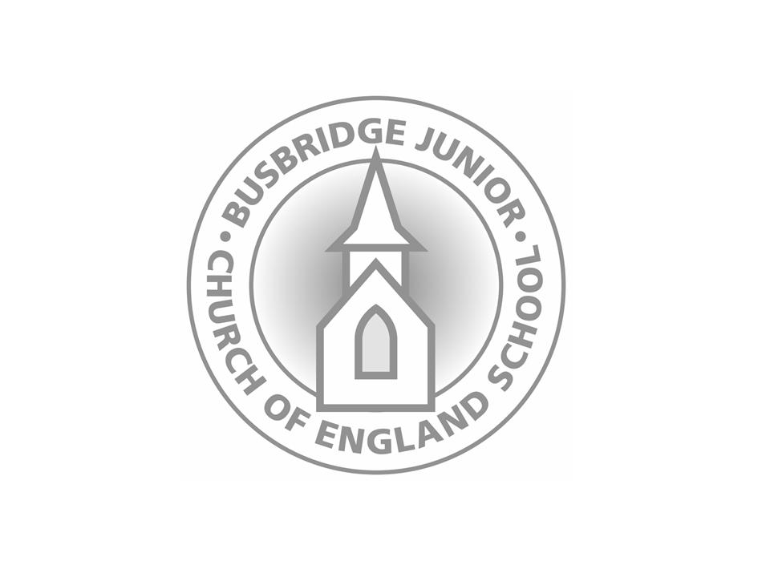

**Godalming Confederation & Partners**

2nd October - 7.15 p.m. - Godalming Junior School

*Godalming Learning Partnership: a co-operative of learning providers in the Godalming area*

