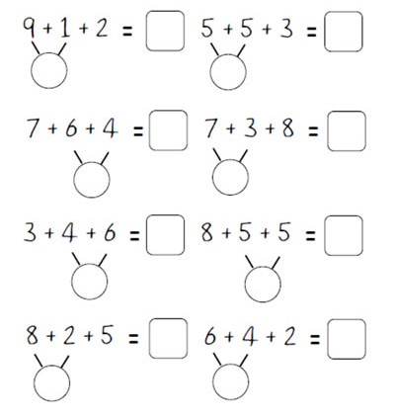
Use your number bonds to 10, to add 3 numbers.

Now try these.

9 + 1 + 5 = 7 + 3 + 5 =

6 + 1 + 4 = 2 + 5 + 8 =

