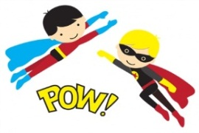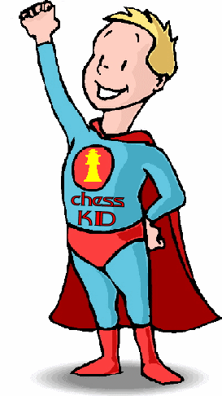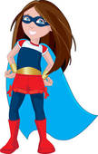 Autumn Term

**Personal, Social and Emotional Development**

* I will be talking about what I like to do at school and what I am good at
* I will be learning about what I need to do to get better and who and what can help me
* I will be learning about listening to my friends
* I will be learning about feelings and how to resolve disagreements with friends
* I will be learning about making good choices
* Our Milford Value is INDEPENDENCE

**Maths**

* I will be learning to recognise and order numbers 1 to 10
* I will be learning to count out objects from a larger group
* I will be counting forwards to 20 and backwards to 0
* I will learn 1 more or 1 less than any number to 10
* I will be learning to select the correct numeral to represent 1 to 10 objects
* I will order three items by length or height
* I will order items by weight and capacity

**Understanding the World**

* I will be talking about why and how things are special (linked to RE)
* I will be finding out about people who help us
* I will be using a recordable device
* I will be learning about different materials

**How you could help at home….**

* *Talk about the importance of practising skills in order to get better*
* *Practise counting forwards and backwards to 20 from any given number*
* *Describe everyday objects in terms of length and height i.e. compare lengths of chips on a dinner plate*
* *Practise reading and writing keywords*
* *Visit parks, museums and libraries*
* *Encourage your child to use both a knife and a fork when eating a meal.*
* *Talk about actions having consequences. What will happen if….*

**Expressive Arts and Design**

* I will be designing my own superhero outfit
* I will be experimenting with a range of collage material to create scenery for my superhero
* I will role-play with my friends as our favourite superheroes
* I will be singing and performing as a group to an audience

**Physical Development**

* I will be designing a superhero exercise workout
* I will be learning that exercise keeps my mind and body strong and healthy
* I will be learning all about ball control, catching and receiving
* I will be developing my superpower pencil control – anti-clockwise movement and retracing vertical lines to help me get better at writing letters

**Communication and Language**

* I will be following more complex instructions
* I will be explaining and understanding prepositions e.g. behind, under, on
* I will be learning new words and using them in conversation with my friends
* I will talk with my Learning Partner at carpet time, listen to their ideas and share them with the class

**Literacy**

* I will be writing about my super powers and sharing it with the class
* I will be listening to and reading non-fiction/information books
* I will be labelling drawings/pictures
* I will be learning my letters and sounds (phase 3 phonics - digraphs)
* I will be writing key words and practising correct letter formation

**Year R – Superheroes**

**Spring Term (1)**